1. Create a Layout using Flexbox?

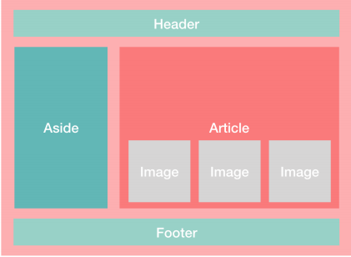

2.Create this Layout using Flexbox?

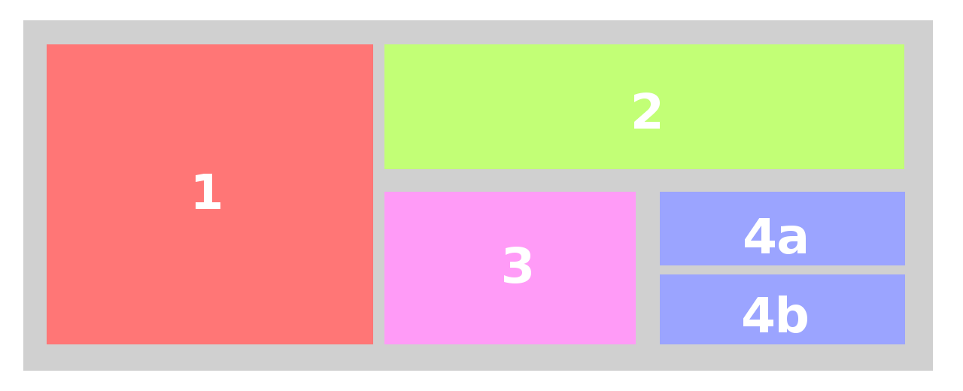

3.Create this layout using Flexbox?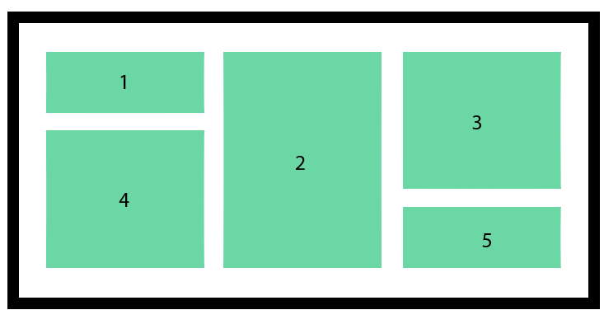

4. Create the below web page by using all the css3 properties.

